Bi-weekly assignment week 7&8 report
Name: Kriti pradhan
Level-3
Section-’c’
Module: Fundamentals of Data Science
Numpy and Pandas.

Create a null vector of size 10 but the fifth value which is 1.
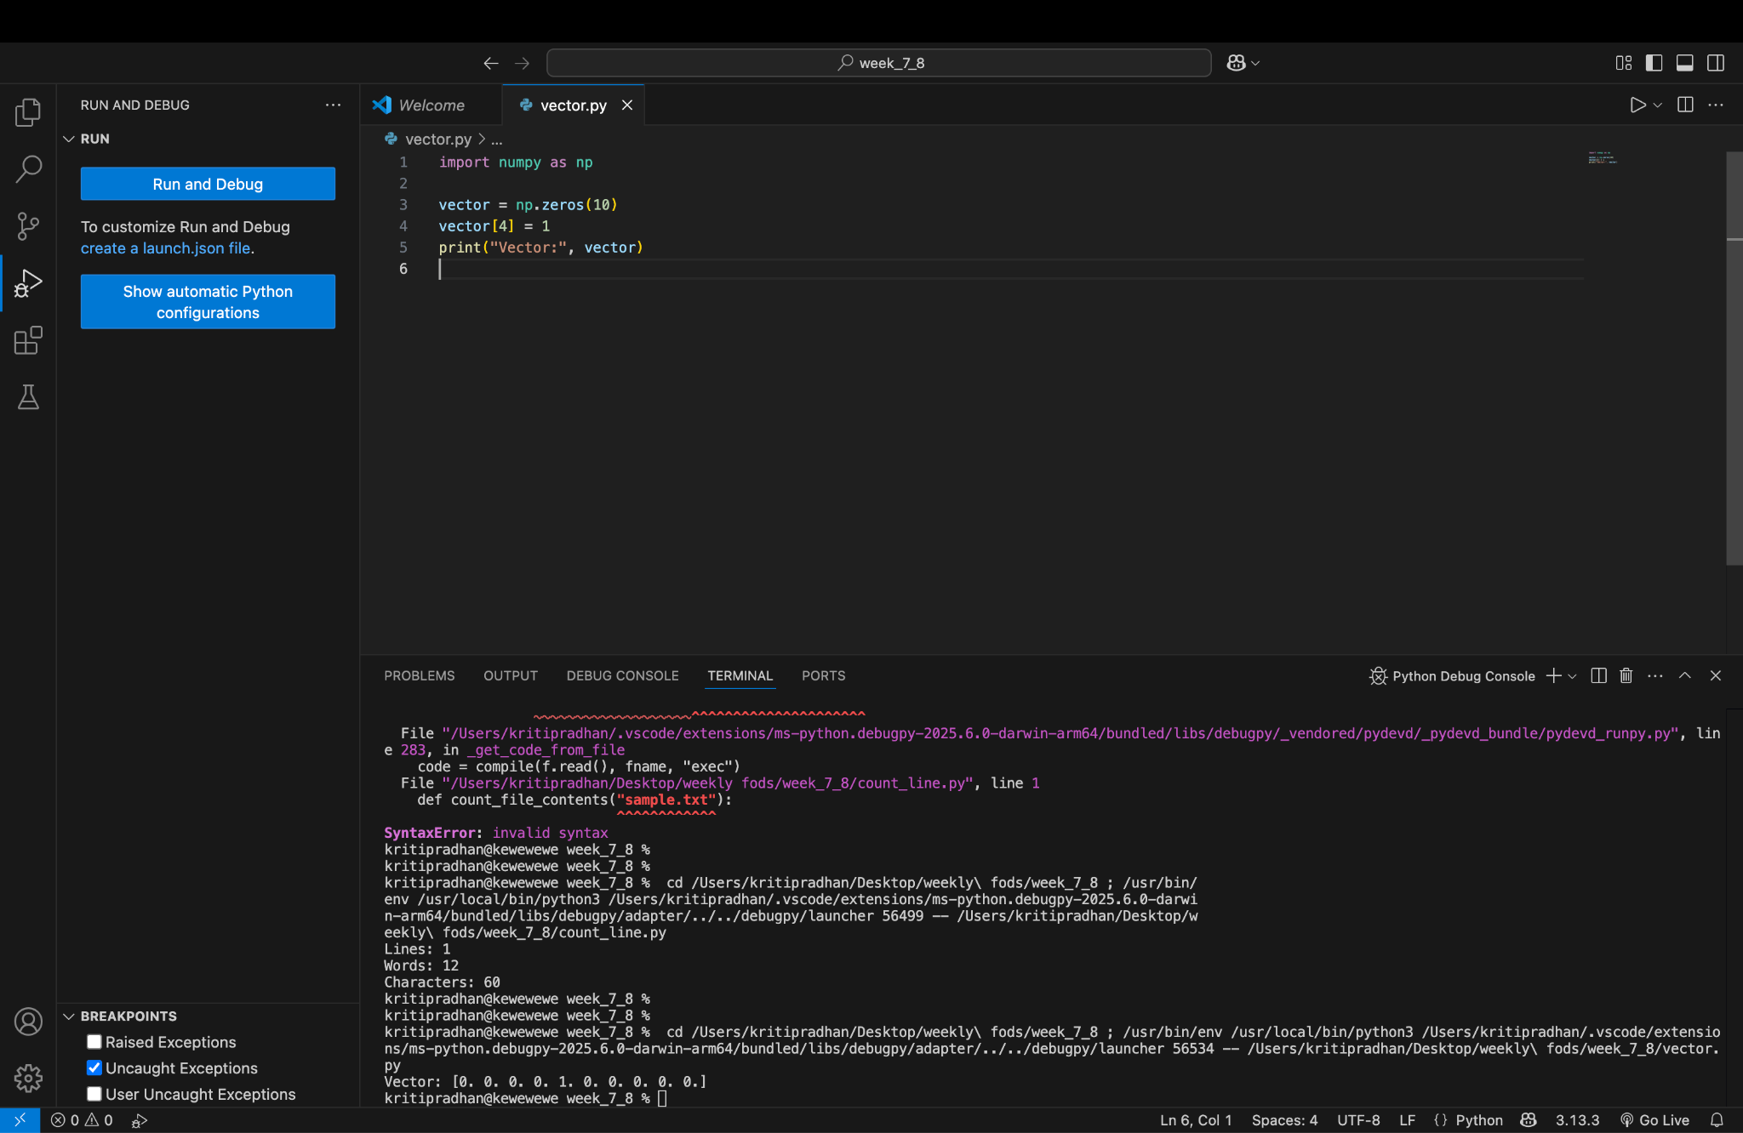

Ask the user to input two numbers a, b. Write a program to generate a random array of shape (a, b) and print the array and avg of the array
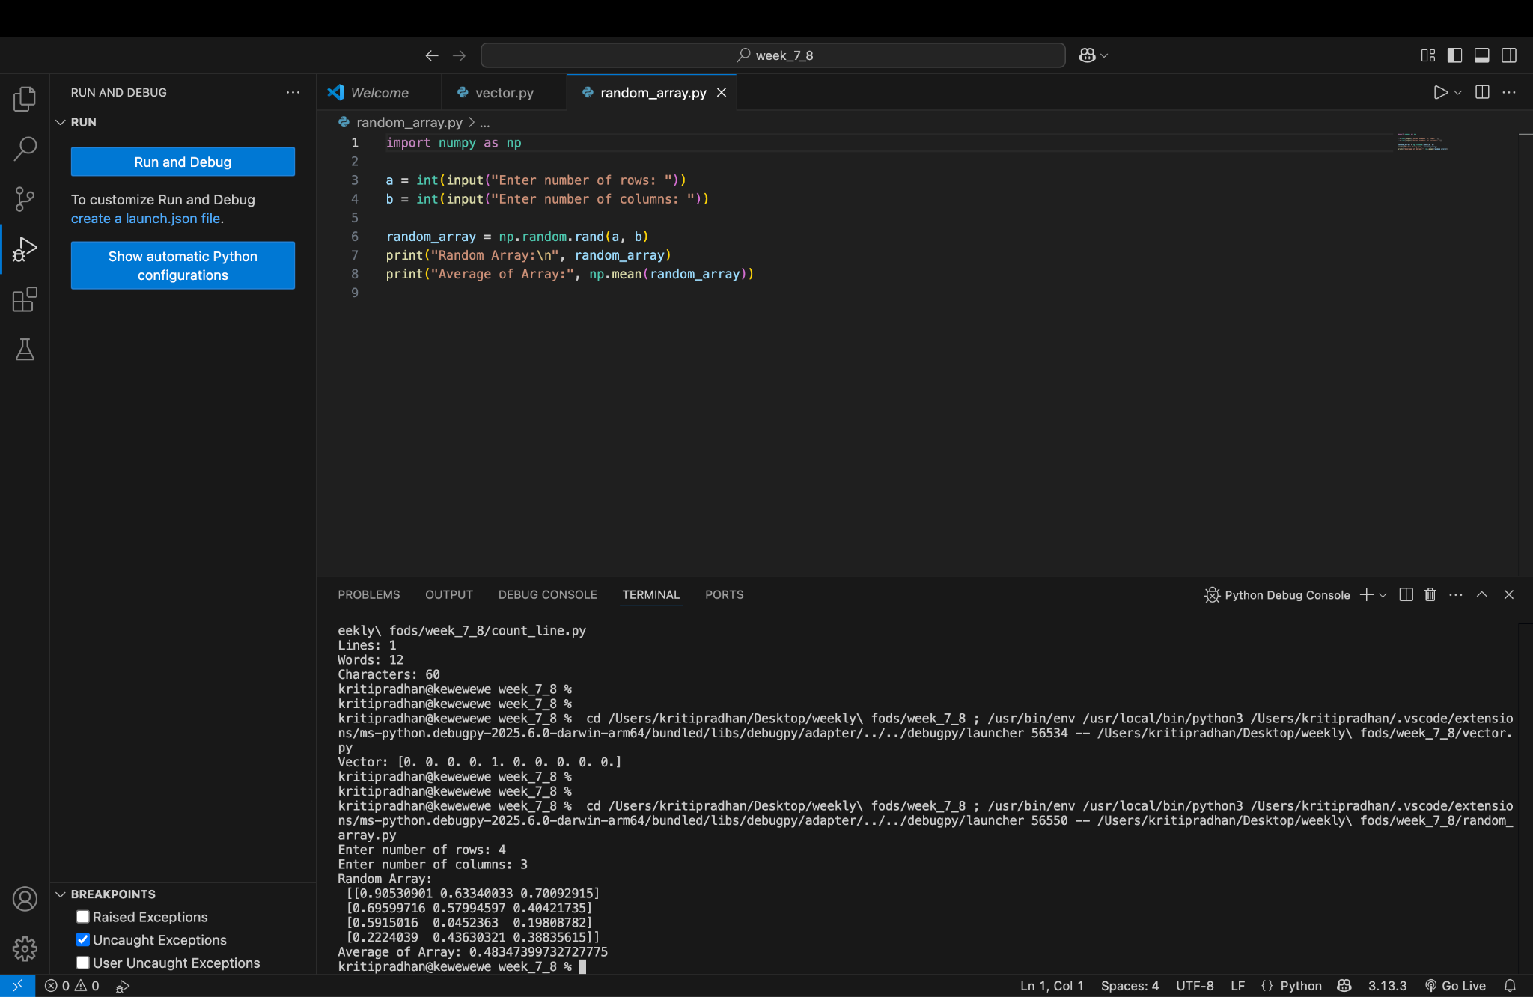
Create a vector of size 10 with values ranging from 0 to 1, both excluded.
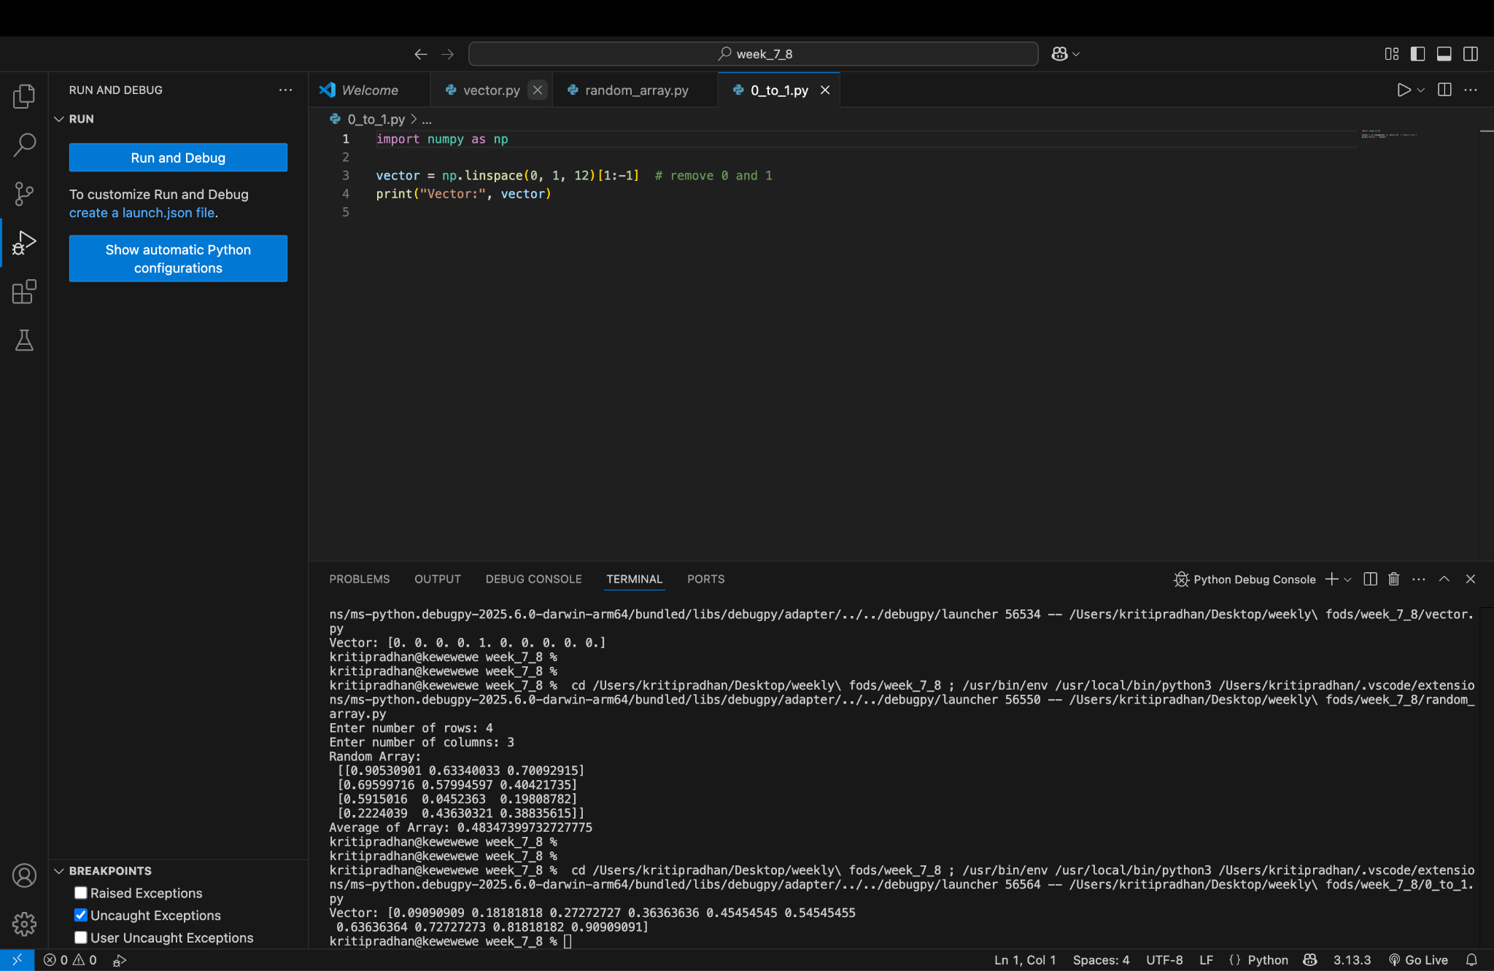

Can you create an identity matrix of shape (3,4). If yes, write code for it.
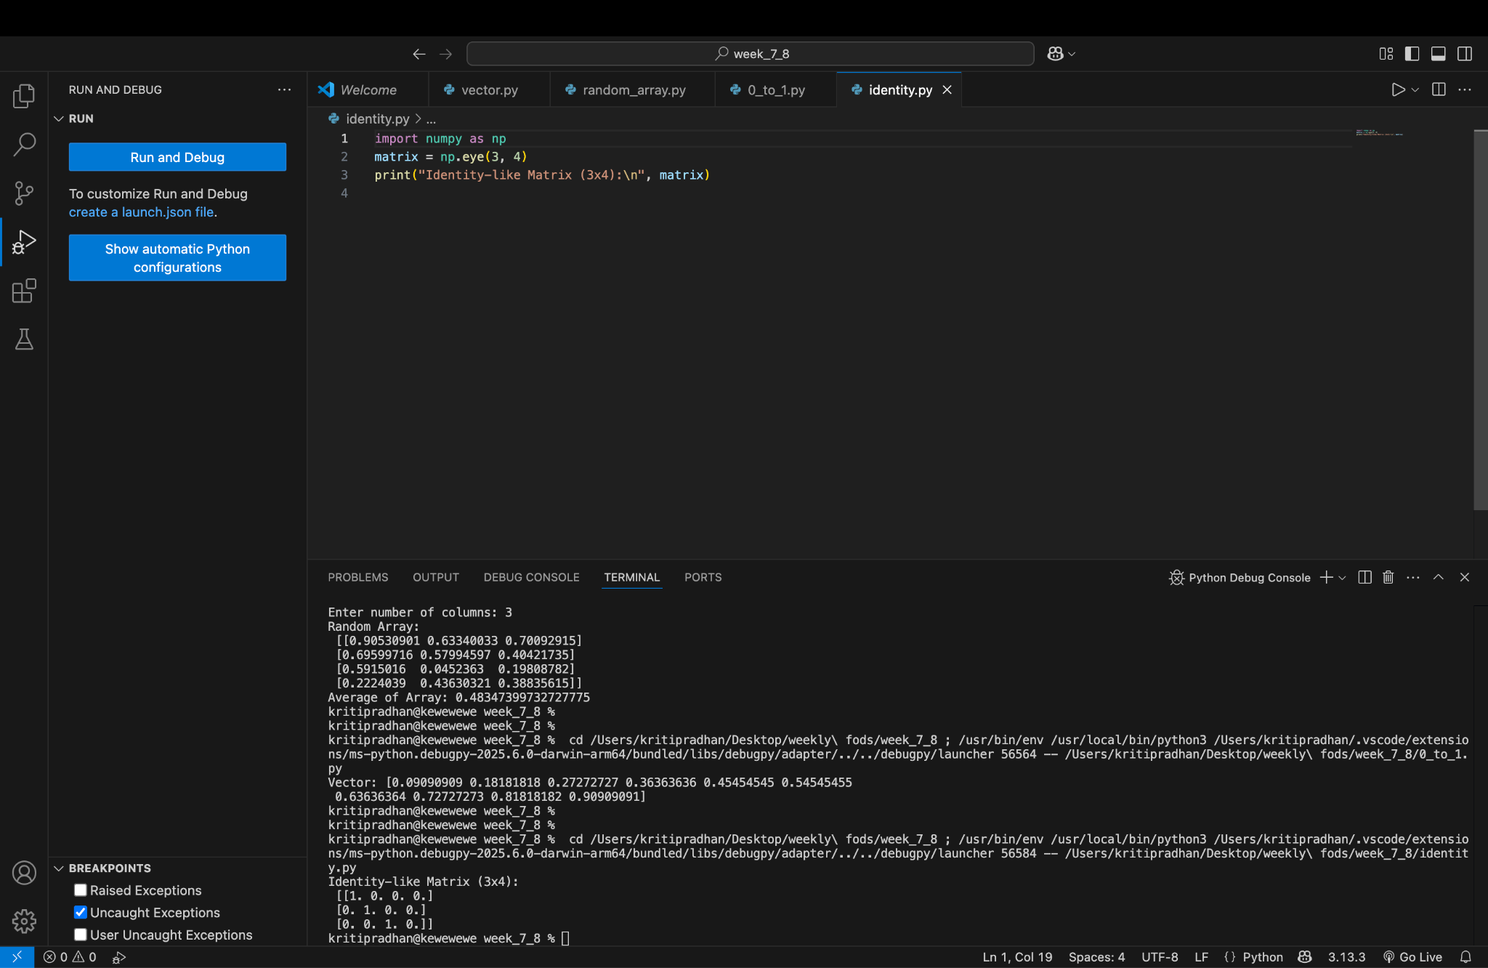
Create a 5x5 matrix with row values ranging from 0 to 4
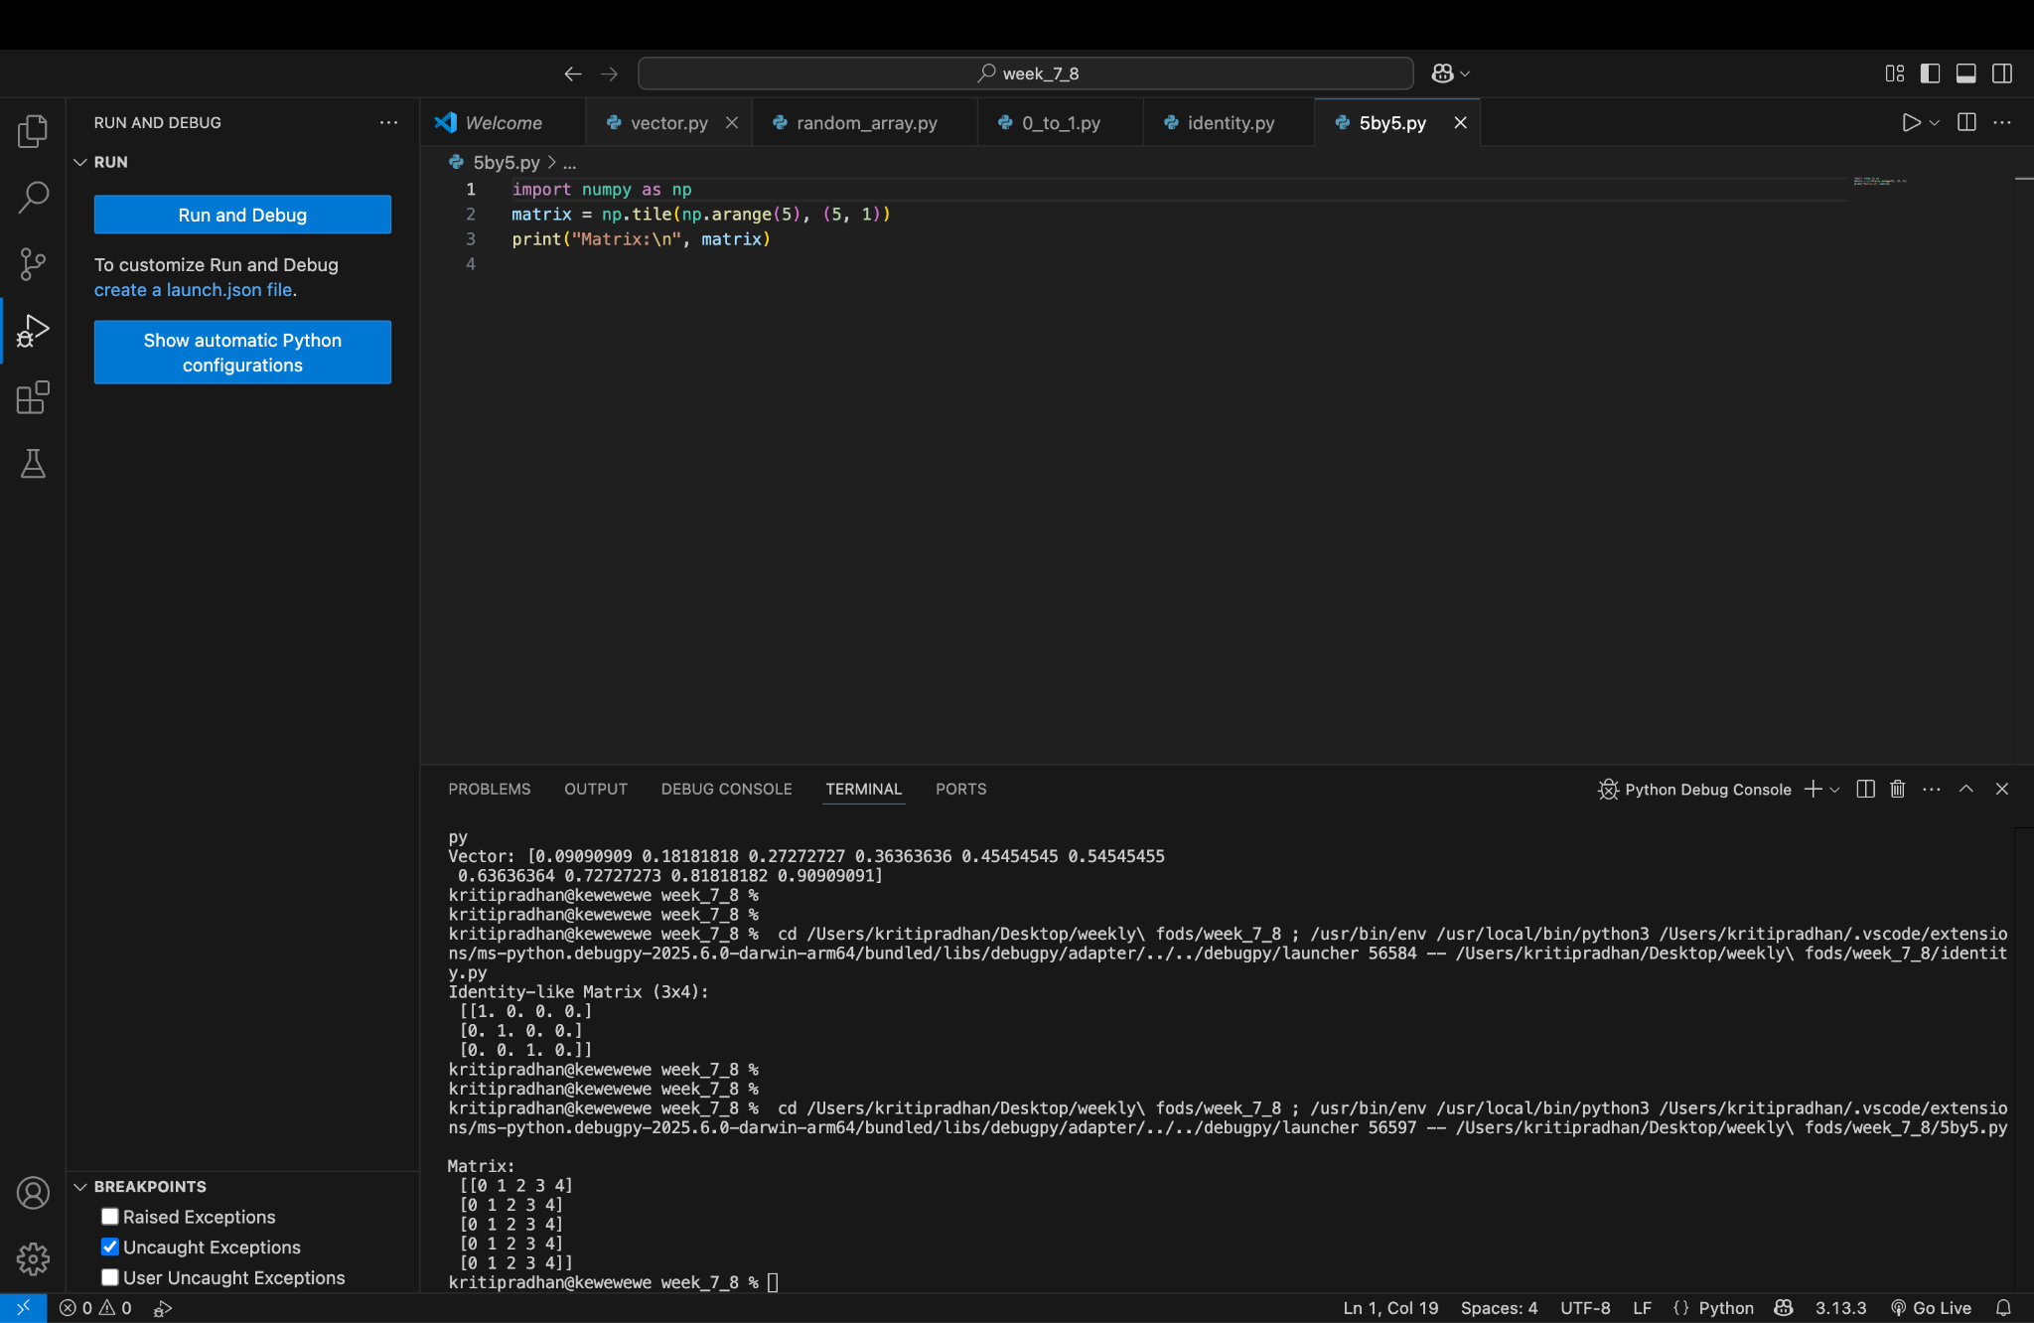

Write a program to input an array of numbers from the user (at least 10 elements in list), sort them and perform slicing operations to get elements between indexes such as 2-5, 5-8, 2-9.
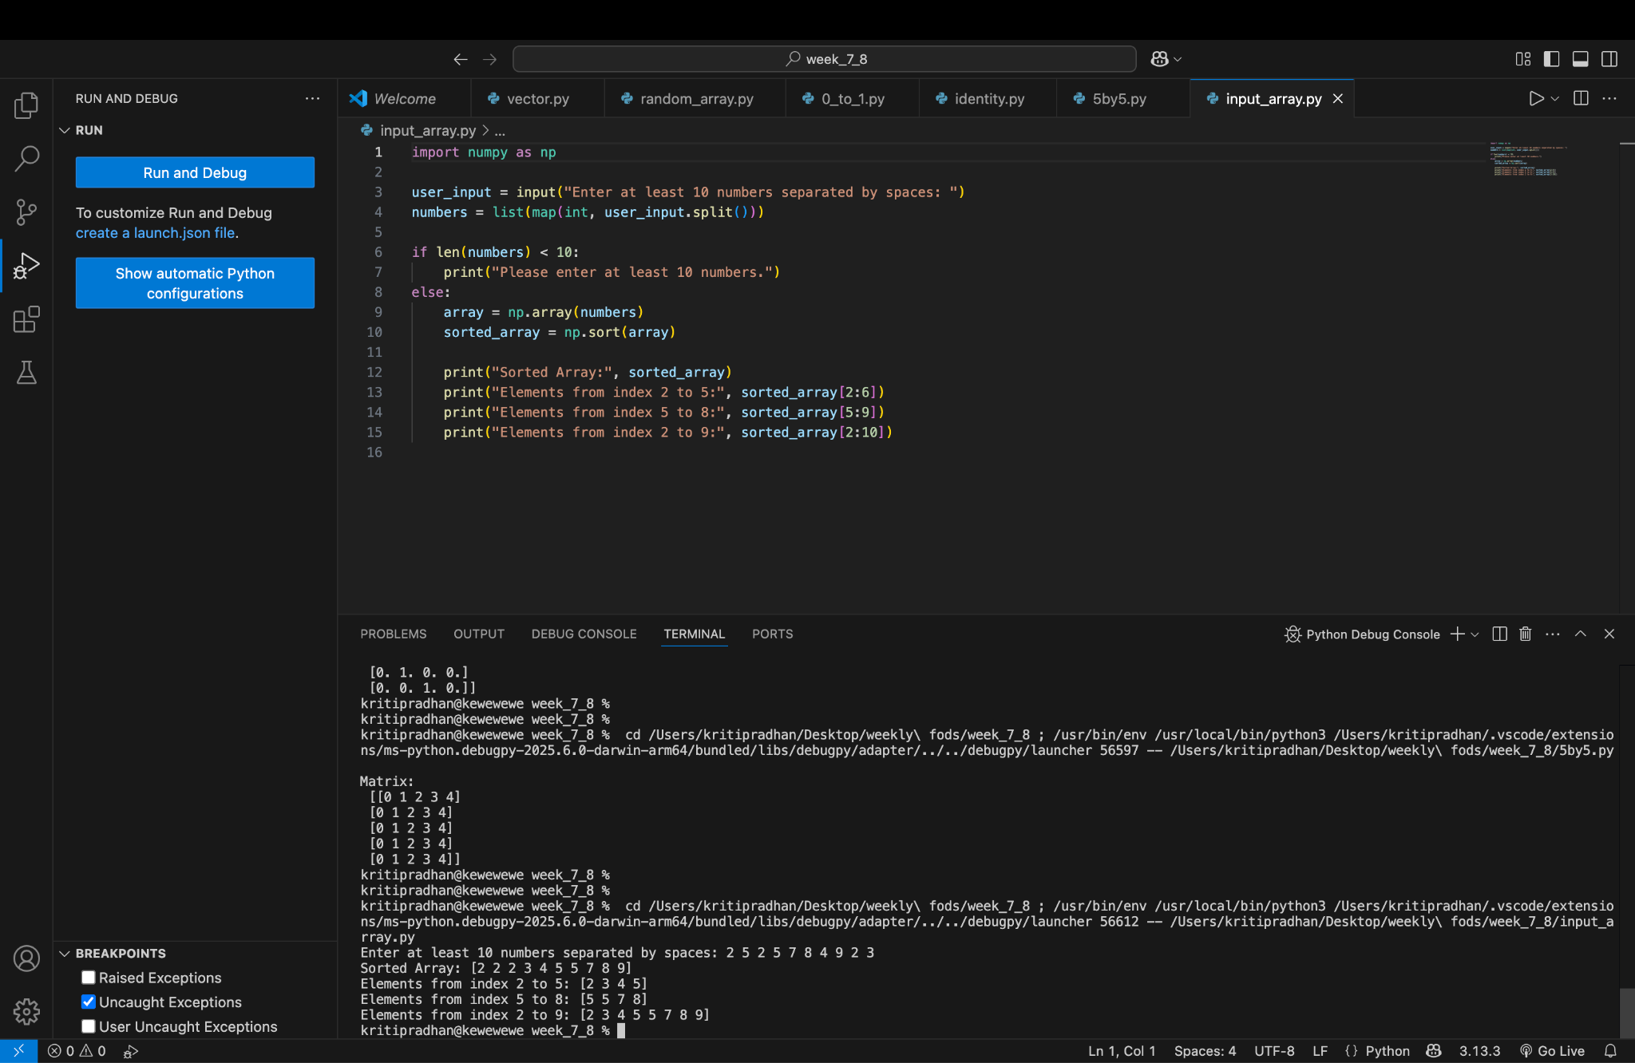
Create an array of random integer numbers as a numpy array, sort them and perform operations such as reshaping the array into a matrix of feasible dimensions. (e.g., if we have an array of 1 * 10, then we can reshape it into 2 * 5 or 5 * 2 matrix.) [Hint: Use the array of reshape (row * column)]
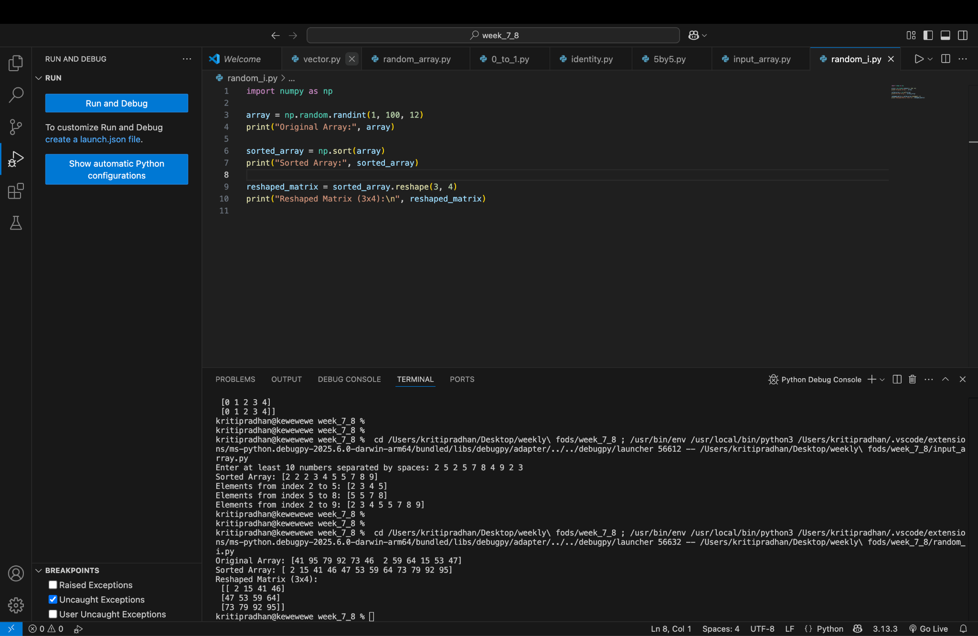

Write a Pandas program to add, subtract, multiple and divide two Pandas Series
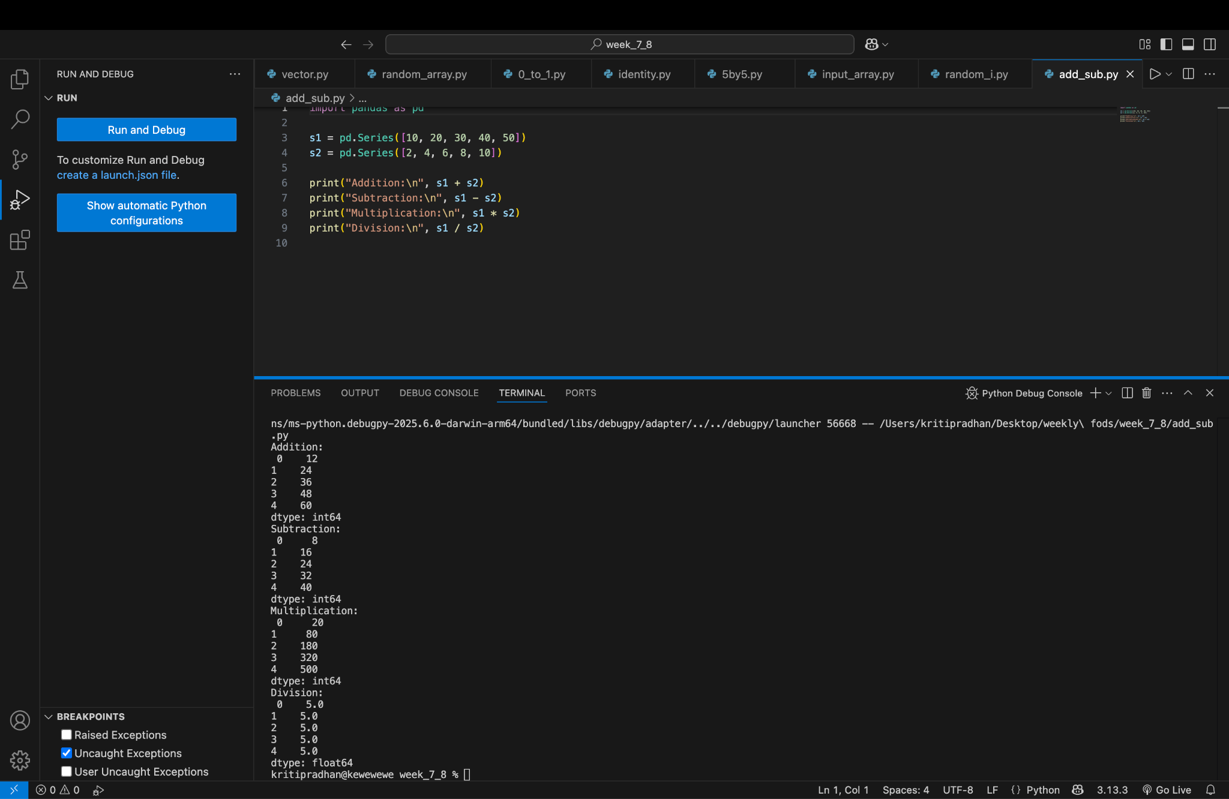
Employee table
